**ĐẠI HỌC TÀI NGUYÊN VÀ MÔI TRƯỜNG TP.HCM**

**KHOA HỆ THỐNG THÔNG TIN VÀ VIỄN THÁM**

***Lớp:*** *HL23_ĐH_LTCoBan*

***Sinh Viên:*** *Thái Xuân Hùng*

***MSSV:*** *1050070037*

***THỰC HÀNH MÔN: LẬP TRÌNH CƠ BẢN***

***GVHD: Phạm Trọng Huynh***

**Lab 3:**

Nội dung

**I Bài tập cơ bản:** 3

**I.1**  3

*I.1.1: Code* 3

*I.1.2: Chạy code:* 3

**I.2** 3

*I.2.1: Code* 3

*I.2.2: Chạy code:* 3

**I.3** 3

*I.3.1: Code* 3

*I.3.2: Chạy code:* 3

**I.4** 3

*I.4.1: Code* 3

*I.4.2: Chạy code:* 3

**I.5** 4

*I.5.1: Code* 4

*I.5.2: Chạy code:* 4

**I.6** 4

*I.6.1: Code* 4

*I.6.2: Chạy code:* 4

**I.7** 4

*I.7.1:**Code* 4

*I.7.2: Chạy code:* 4

**I.8** 4

*I.8.1: Code* 4

*I.8.2: Chạy code:* 4

**I.9** 4

*I.9.1: Code* 4

*I.9.2: Chạy code:* 4

**I.10** 4

*I.10.1: Code* 4

*I.10.2: Chạy code:* 4

# **I Bài tập cơ bản:**

## **I.1**

### *I.1.1: Code*

**#include<iostream>**

**using namespace std;**

**int min(int a, int b) {**

**return (a < b) ? a : b;**

**}**

**int min(int a, int b, int c) {**

**return min(min(a, b), c);**

**}**

**int main() {**

**int n1, n2, n3, n4, n5;**

**cout << "Nhap so thu nhat va thu hai: ";**

**cin >> n1 >> n2;**

**int mina = min(n1, n2);**

**cout << "So nho hon trong hai so la: " << mina << endl;**

**cout << "Nhap so thu nhat, thu hai va thu ba: ";**

**cin >> n3 >> n4 >> n5;**

**int minb = min(n3, n4, n5);**

**cout << "So nho hon trong ba so la: " << minb << endl;**

**return 0;**

**}**

### *I.1.2: Chạy code:*

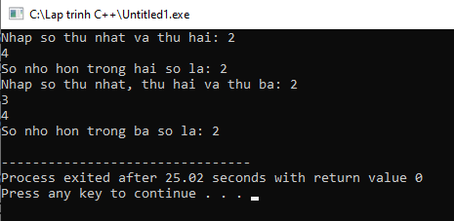

## **I.2**

### *I.2.1: Code*

*#include<iostream>*

*using namespace std;*

*int UocChung(int a,int b){*

*for(int i=min(a,b);i>0;i--){*

*if(a%i==0&&b%i==0){*

*return i;*

*break;*

*}*

*}*

*}*

*int BoiChung(int a,int b){*

*for(int i=max(a,b);i<=a*b;i++){*

*if(i%a==0&&i%b==0){*

*return i;*

*break;*

*}*

*}*

*}*

*int main(){*

*int a,b;*

*cout<<"Nhap hai so:";cin>>a>>b;*

*cout<<"Uoc chung lon nhat cua "<<a<<" va "<<b<<" la:"<<UocChung(a,b)<<endl;*

*cout<<"Boi chung nho nhat cua "<<a<<" va "<<b<<" la:"<<BoiChung(a,b)<<endl;*

*}*

### *I.2.2: Chạy code:*

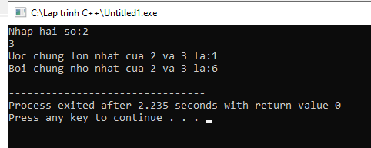

## **I.3**

### *I.3.1: Code*

*#include<iostream>*

*using namespace std;*

*int GiaiThua(int n){*

*int S=1;*

*for(int i=1;i<=n;i++){*

*S=S*i;*

*}*

*return S;*

*}*

*int main(){*

*int n;*

*Nhap:*

*cout<<"Nhap so:";cin>>n;*

*if(n<1){*

*cout<<"Khong hop le!"<<endl;*

*goto Nhap;*

*}*

*cout<<"Giai thua cua "<<n<<" la:"<<GiaiThua(n);*

*}*

### *I.3.2: Chạy code:*

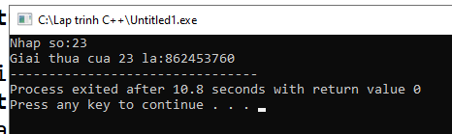

## **I.4**

### *I.4.1: Code*

*#include<iostream>*

*using namespace std;*

*int Tinh(int x,int n){*

*int S=1;*

*for(int i=1;i<=n;i++){*

*S=S*x;*

*}*

*return S;*

*}*

*int main(){*

*int x,n;*

*cout<<"Nhap X:";cin>>x;*

*cout<<"Nhap n:";cin>>n;*

*cout<<"X^n="<<Tinh(x,n);*

*}*

### *I.4.2: Chạy code:*

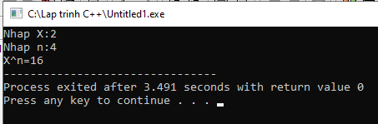

## **I.5**

### *I.5.1: Code*

*#include<iostream>*

*using namespace std;*

*int GiaiThua(int n){*

*int S=1;*

*for(int i=1;i<=n;i++){*

*S=S*i;*

*}*

*return S;*

*}*

*int ToHop(int n,int k){*

*int C;*

*C=(GiaiThua(n))/(GiaiThua(k)*GiaiThua(n-k));*

*}*

*int main(){*

*int n,k;*

*cout<<"Nhap n:";cin>>n;*

*cout<<"Nhap k:";cin>>k;*

*cout<<"C(n,k)="<<ToHop(n,k);*

*}*

### *I.5.2: Chạy code:*

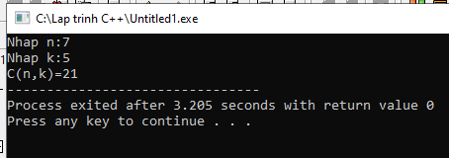

## **I.6**

### *I.6.1: Code*

*#include<iostream>*

*using namespace std;*

*void Ve(int r,int d){*

*for(int i=0;i<r;i++){*

*for(int j=0;j<d;j++){*

*if(i==0||i==r-1||j==0||j==d-1)*

*cout<<"* ";*

*else*

*cout<<" ";*

*}*

*cout<<endl;*

*}*

*}*

*int ChuVi(int r,int d){*

*return (d+r)*2;*

*}*

*int DienTich(int r,int d){*

*return d*r;*

*}*

*int main(){*

*int r,d;*

*cout<<"Nhap chieu rong va chieu dai:";cin>>r>>d;*

*Ve(r,d);*

*cout<<"Chu vi cua hinh chu nhat:"<<ChuVi(r,d)<<endl;*

*cout<<"Dien tich hinh chu nhat:"<<DienTich(r,d)<<endl;*

*}*

### *I.6.2: Chạy code:*

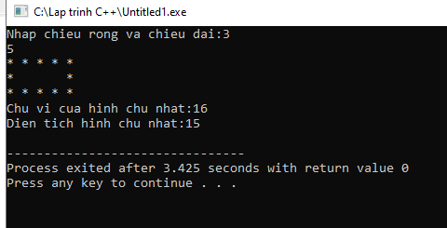

## **I.7**

### *I.7.1:* *Code*

### *I.7.2: Chạy code:*

## **I.8**

### *I.8.1: Code*

*#include<iostream>*

*using namespace std;*

*void Tien(int n){*

*int NamChuc=n/50000;*

*n=n%50000;*

*int HaiChuc=n/20000;*

*n=n%20000;*

*int MotChuc=n/10000;*

*n=n%10000;*

*int NamNghin=n/5000;*

*n=n%5000;*

*int HaiNghin=n/2000;*

*n=n%2000;*

*int MotNghin=n/1000;*

*n=n%1000;*

*cout<<NamChuc<<"x50.000 "<<HaiChuc<<"x20000 "<<MotChuc<<"x10000 "<<NamNghin<<"x5000 "<<HaiNghin<<"x2000 "<<MotNghin<<"x1000";*

*}*

*int main(){*

*int n;*

*Nhap:*

*cout<<"Nhap so tien:";cin>>n;*

*if(n<0||n%100!=0){*

*cout<<"Khong hop le!";*

*goto Nhap;*

*}*

*Tien(n);*

*}*

### *I.8.2: Chạy code:*

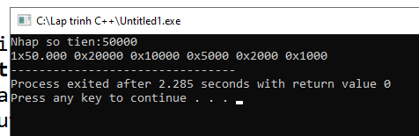

## **I.9**

### *I.9.1: Code*

*#include<iostream>*

*using namespace std;*

*int Dao(int n){*

*int S=0;*

*while(n>0){*

*S=S*10+n%10;*

*n=n/10;*

*}*

*return S;*

*}*

*int main(){*

*int n;*

*cout<<"Nhap n:";cin>>n;*

*cout<<"So dao:"<<Dao(n);*

*}*

### *I.9.2: Chạy code:*

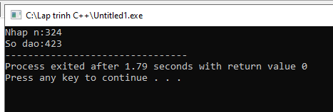

## **I.10: Xếp loại các học sinh trong lớp theo yêu cầu đề bài**

### *I.10.1: Code*

### *I.10.2: Chạy code:*